
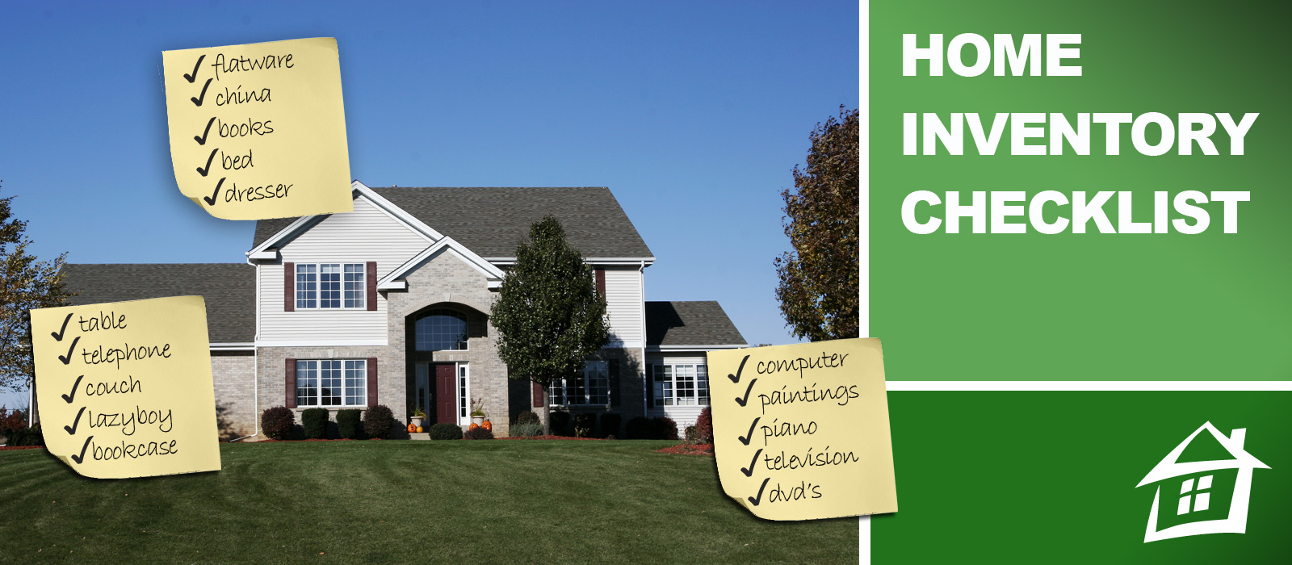
RC Insurance Services, Inc.

1320 Walnut Ridge Drive, Ste 200
Hartland, WI
53029
Tel: 262-367-8611
www.rcinsure.com

Brought to you by:

Why create a home inventory checklist?

Though your homeowners insurance policy provides the protection that you need in the event of a loss such as a fire or burglary, your policy can only pay for items that you can document. In order to assure that all your prize possessions will be replaced, you should conduct a home inventory so you have a finite record of everything that you own. This inventory will assist you in determining which items were destroyed or stolen.

How should you conduct a home inventory?

To complete a full home inventory, walk through every room in your home and identify all of the contents. It is also wise to take photographs or make a video of all of your possessions, and keep this media documentation with your list. Then, place all of this information into a fire-proof safe or safety deposit box at your bank.

Periodically, update this list as you purchase more items for your home.

How does a home inventory list relate to my insurance policy?

Not only can a household inventory checklist assist you in the event of a loss, it can also help you determine whether you have enough insurance coverage. Your coverage should equal the cost of your possessions at today’s prices. Items such as jewelry, furs and fine art should be appraised on a regular basis to ensure that you have enough insurance to cover their high-priced value.

Once you have completed your home inventory walk-thru, contact RC Insurance Services, Inc. for more assistance with your insurance needs.

Name: _____________________________

Address: _____________________________
City: ____________ State: _____ Zip: _____

Date of Original Inventory: _________

Revised On: _________

Revised On: _________

Revised On: _________

Revised On: _________

Revised On: _________

HOME INFORMATION

Year Built: _________ Builder: _________
Sq. Footage: _________ Lot: _________
Purchased On: _________ Price: _________
Previous Owners: _________________________
Mortgage Company: _________________________
Location of Plot Plan: _________________________
Location of Deed: _________________________

INSURANCE INFORMATION

Homeowners: _______________________________
Earthquake: __________ Mortgage: __________
Flood: __________ Fire: __________

APPRAISALS

Amount: _____________ Year: ___________
Amount: _____________ Year: ___________
Amount: _____________ Year: ___________
Amount: _____________ Year: ___________

LIVING ROOM
ITEM DESCRIPTION | # OF | DATE PURCHASED | PRICE
Sofas
Chairs
Lamps
Rugs
Tables
Curtains
Draperies
Window Hardware
Mirrors
Clocks
Radios
Piano
Stereo
Paintings (attach list)
Desk
Fireplace Equipment (attach list)
Bookcases
Television
Video Games (attach list)
Tapes (attach list)
Compact Discs (attach list)
VCR
DVD Player
DVDs
Window Air Conditioner
Ceiling Fan
Computer
Desk
Board games/Toys (attach list)
Telephone
Cabinets and Contents (attach list)
Additional Items
TOTAL
DINING ROOM
ITEM DESCRIPTION | # OF | DATE PURCHASED | PRICE
Buffet
Chairs
Lamps
Rugs
Table
Curtains
Draperies
Window Hardware
Mirrors
Clocks
China
Crystal
Linens
Silver (attach list)
Flatware
Paintings (attach list)
Appliances (attach list)
Cabinets and Contents (attach list)
Wall Shelving
China Cabinet
Additional Items
TOTAL
KITCHEN
ITEM DESCRIPTION | # OF | DATE PURCHASED | PRICE
Stove/Oven
Refrigerator
Dishwasher
Table
Chairs
Cabinets and Contents (attach list)
Utensils
Cutlery
Dishes (attach list)
Glassware
Freezer
Microwave
Rotisserie
Food Processor
Mixer
Blender
Radio
Clock
Television
Ceiling Fan
Cookbooks
Crystal
Foods
Garbage Disposal
Linens
Liquors
Pots and Pans
Small Appliances
Telephone
Additional Items
TOTAL
LAUNDRY ROOM
ITEM DESCRIPTION | # OF | DATE PURCHASED | PRICE
Washer
Dryer
Ironing Board
Iron
Cabinets and Contents (attach list)
Closet Contents (attach list)
Additional Items
TOTAL
FAMILY ROOM/DEN
ITEM DESCRIPTION | # OF | DATE PURCHASED | PRICE
Bookcases
Books
Cabinets and Contents (attach list)
Compact Discs (attach list)

Ceiling Fan
Chairs
Clocks
Closet Contents (attach list)
Computer
Couches
Desk
Drapes
Curtains
Window Hardware
Electronic Games (attach list)
Entertainment Center
Fireplace Equipment (attach list)
Games/Toys (attach list)
Hobby Equipment (attach list)
Lamps
Piano
Pictures
Rugs
Tables
Telephone
Television
VCR
DVDs (attach list)
DVD Player
Tapes (attach list)
Wall Shelving
Window Air Conditioner
Additional Items
TOTAL
BATHROOM #1
ITEM DESCRIPTION | # OF | DATE PURCHASED | PRICE
Whirlpool
Cabinets and Contents (attach list)
Hamper
Linens
Hair Dryer
Scale
Shower Curtain
Rugs
Electric Razors
Mirrors
Appliances (attach list)
Medications (attach list)
Additional Items
TOTAL
BATHROOM #2
ITEM DESCRIPTION | # OF | DATE PURCHASED | PRICE
Whirlpool
Cabinets and Contents (attach list)
Hamper
Linens
Hair Dryer
Scale
Shower Curtain
Rugs
Electric Razors
Mirrors
Appliances (attach list)
Medications (attach list)
Additional Items
TOTAL
BATHROOM #3
ITEM DESCRIPTION | # OF | DATE PURCHASED | PRICE
Whirlpool
Cabinets and Contents (attach list)
Hamper
Linens
Hair Dryer
Scale
Shower Curtain
Rugs
Electric Razors
Mirrors
Appliances (attach list)
Medications (attach list)
Additional Items
TOTAL
HALLWAYS
ITEM DESCRIPTION | # OF | DATE PURCHASED | PRICE
Humidifier
Rugs
Mirrors
Paintings (attach list)
Pictures (attach list)
Chairs
Furniture (attach list)
Additional Items
TOTAL
BEDROOM #1
ITEM DESCRIPTION | # OF | DATE PURCHASED | PRICE
Bed
Mattress/Box Spring
Bedding
Chairs
Dressers
Rugs
Tables
Curtains
Window Hardware
Mirrors
Clocks
Radios
Linens
Desk
Nightstands
Lamps
Paintings (attach list)
Window Air Conditioner
Television
VCR
DVD Player
Cabinets and Contents (attach list)
Games/Toys (attach list)
Men’s Clothing (attach list)
Women’s Clothing (attach list)
Children’s Clothing (attach list)
Shoes (attach list)
Handbags (attach list)
Additional Items
TOTAL
BEDROOM #2
ITEM DESCRIPTION | # OF | DATE PURCHASED | PRICE
Bed
Mattress/Box Spring
Bedding
Chairs
Dressers
Rugs
Tables
Curtains
Window Hardware
Mirrors
Clocks
Radios
Linens
Desk
Nightstands
Lamps
Paintings (attach list)
Window Air Conditioner
Television
VCR
DVD Player
Cabinets and Contents (attach list)
Games/Toys (attach list)
Men’s Clothing (attach list)
Women’s Clothing (attach list)
Children’s Clothing (attach list)
Shoes (attach list)
Handbags (attach list)
Additional Items
TOTAL
BEDROOM #3
ITEM DESCRIPTION | # OF | DATE PURCHASED | PRICE
Bed
Mattress/Box Spring
Bedding
Chairs
Dressers
Rugs
Tables
Curtains
Window Hardware
Mirrors
Clocks
Radios
Linens
Desk
Nightstands
Lamps
Paintings (attach list)
Window Air Conditioner
Television
VCR
DVD Player
Cabinets and Contents (attach list)
Games/Toys (attach list)
Men’s Clothing (attach list)
Women’s Clothing (attach list)
Children’s Clothing (attach list)
Shoes (attach list)
Handbags (attach list)
Additional Items
TOTAL
BEDROOM #4
ITEM DESCRIPTION | # OF | DATE PURCHASED | PRICE
Bed
Mattress/Box Spring
Bedding
Chairs
Dressers
Rugs
Tables
Curtains
Window Hardware
Mirrors
Clocks
Radios
Linens
Desk
Nightstands
Lamps
Paintings (attach list)
Window Air Conditioner
Television
VCR
DVD Player
Cabinets and Contents (attach list)
Games/Toys (attach list)
Men’s Clothing (attach list)
Women’s Clothing (attach list)
Children’s Clothing (attach list)
Shoes (attach list)
Handbags (attach list)
Additional Items
TOTAL
BEDROOM #5
ITEM DESCRIPTION | # OF | DATE PURCHASED | PRICE
Bed
Mattress/Box Spring
Bedding
Chairs
Dressers
Rugs
Tables
Curtains
Window Hardware
Mirrors
Clocks
Radios
Linens
Desk
Nightstands
Lamps
Paintings (attach list)
Window Air Conditioner
Television
VCR
DVD Player
Cabinets and Contents (attach list)
Games/Toys (attach list)
Men’s Clothing (attach list)
Women’s Clothing (attach list)
Children’s Clothing (attach list)
Shoes (attach list)
Handbags (attach list)
Additional Items
TOTAL
ATTIC/BASEMENT/GARAGE
ITEM DESCRIPTION | # OF | DATE PURCHASED | PRICE
Lawnmower
Snow Blower
Ladders
Barbeque/Grill
Chairs
Dehumidifier
Luggage
Hand Tools (attach list)
Workbench
Heating Unit
Freezer
Vacuum Cleaner
Auto Equipment (attach list)
Bicycles
Garden Furniture
Garden Tools
Lawn Furniture
Power Tools (attach list)
Rugs
Sports Equipment (attach list)
Storage Shelving
Furniture
Trunks
Additional Items
TOTAL
HOBBY ITEMS (List each)
ITEM DESCRIPTION | # OF | DATE PURCHASED | PRICE
Cameras
Golf Equipment
Ski Equipment
Boating Equipment
Paint Set
Pool Table
Exercise Equipment
Hunting Equipment
Fishing Equipment
Stamp Collection
Carving Set
Sewing Machine
Bowling Equipment
Camping Equipment
Games
Ice Skating Equipment
Tennis Equipment
Additional Items
TOTAL
OFFICE EQUIPMENT
ITEM DESCRIPTION | # OF | DATE PURCHASED | PRICE
Home Computer
Modem
Hard Drive
Scanner
Printer
Fax Machine
Additional Items
TOTAL
SPECIAL VALUABLE ITEMS (List each)
ITEM DESCRIPTION | # OF | DATE PURCHASED | PRICE
Antiques
Bracelets
Brooches
Central Air Conditioning Unit
Central Heating Unit
Earrings
Fine Art
Firearms
Furs
Hobby Collections
Necklaces
Other Jewelry
Rings
Watches
Sculptures
Handbags
Additional Items
TOTAL
OTHER
ITEM DESCRIPTION | # OF | DATE PURCHASED | PRICE
TOTAL
SUMMARY

Page

4 Living Room $______
5 Dining Room $______
6 Kitchen $______
7 Laundry Room $______
8 Family Room/Den $______
9 Bathroom #1 $______
10 Bathroom #2 $______
11 Bathroom #3 $______
12 Hallways $______
13 Bedroom #1 $______
14 Bedroom #2 $______
15 Bedroom #3 $______
16 Bedroom #4 $______
17 Bedroom #5 $______
18 Attic/Basement/Garage $______
19 Hobby Items $______
20 Office Equipment $______
21 Valuables $______
22 Other Items $______

TOTAL: $______

PRESENT INSURANCE: $______

ADDITIONAL INSURANCE: $______

TOTAL INSURANCE NOW: $______

DATE: ______

